MACH4METAL

metalworking machinery
Transito 21
6909 DA BABBERICH Netherlands
Tel. +31 (0)316-247123
Fax: +31 (0)316-247956
info@mach4metal.com
www.mach4metal.com

Bank No : 66.52.13.883
IBAN : NL33 INGB 0665 2138 83
BIC : INGBNL2A

4 ROLL PLATE BENDER
STÖLTING 3250 X 20 MM
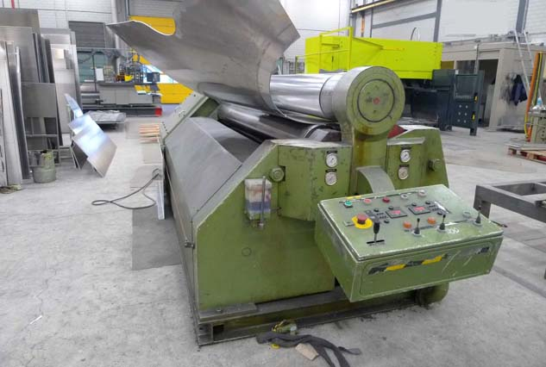
- Make : Stolting - Deutchland
- Typ : VB
- Serial No :
- Age : 1991

- Rolling width : 3.250 mm
- Rolling thickness : 20 mm x R 2500
- Pre bending : 13 mm x R 2500

- Top roll Ø : 380
- Side roll Ø : 300
- Lower roll Ø : 380

- Rolling speed : 4 M/min
- Power : 22 kW
- Adjustment top roll : 0 – ? mm/Min
- Adjustment side roll : 0 – ? mm/Min

- Top support load ….
- Side support load…
- Length : 7.500
- Width : 2.400
- Height : 4.400
- Weight : 21.000 KG

- Conical bending
- Oil cooler

Please Note: The above information has been obtained to the best of our ability and belief from, and from the manufacturers where possible. It is given in good faith, but its accuracy can not be guaranteed. Accordingly, it will not form a representation or constitute contractual terms. We advise you to check any vital details!

